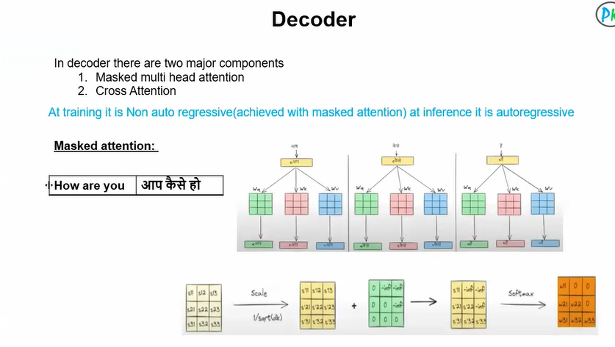

Multi-Head Attention in Transformers (often called “multi masked attention” in decoder)
In the Attention Is All You Need Transformer architecture, Multi-Head Attention (MHA) is the core idea that allows the model to focus on different parts of a sentence at the same time.

What is Attention?
Attention lets a word look at other words and decide:
“Which words are important for understanding me?”
Example:
“The animal didn’t cross the street because it was tired.”
To understand “it”, the model must attend to “animal.”

What is Multi-Head Attention?
Instead of doing attention once, the model does it multiple times in parallel.
Each attention unit is called a head.
Multi-Head Attention = Multiple Attention heads running in parallel
Each head learns something different:
- One head → grammar relations
- One head → long-distance dependency
- One head → subject-verb relation
- One head → positional relationship

Why Multiple Heads?
Because one attention view is limited.
Imagine reading a sentence:
- One brain looks at grammar
- One brain looks at meaning
- One brain looks at context
More heads = richer understanding
Mathematical Idea
Each head computes:
Attention(Q, K, V) = softmax(QKᵀ / √dₖ) V
- Q = Query
- K = Key
- V = Value
- dₖ = dimension of key
Then:
MultiHead(Q,K,V) = Concat(head₁, head₂, … headₙ) Wᵒ
So:
- Split embeddings into multiple parts
- Apply attention separately
- Concatenate results
- Project back to original size

What is “Masked” Multi-Head Attention?
This is used only in the decoder.
In decoder:
We mask future words so the model cannot cheat.
Example:
For sentence:
I love machine learning
When predicting "machine", the model must NOT see:
- "learning"
So we apply a causal mask:
Allowed attention:
Word1 → Word1
Word2 → Word1, Word2
Word3 → Word1, Word2, Word3
Multi-Head Attention allows:
- Parallel processing (unlike RNNs)
- Long-range dependency capture
- Better contextual embeddings
- Scalability (used in GPT, BERT, etc.)
Multi-Head Attention = Multiple attention mechanisms running in parallel to capture different relationships in text.
Masked version = Prevents looking at future tokens during generation.
